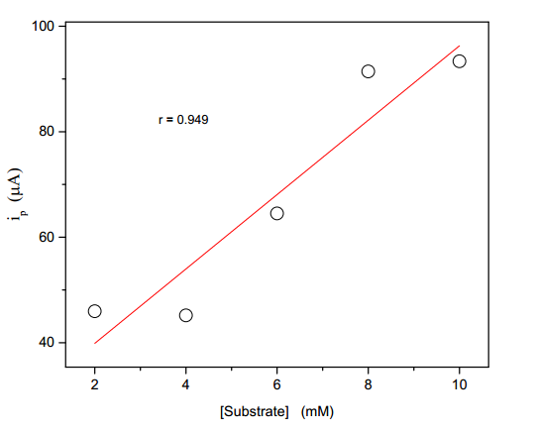

Fig. 9. Plot of second peak (ip) versus concentration of of (E)-1-(furan-2-yl)-3-

phenylprop-2-ene-1-ones in tetra butyl ammonium tetra fluoroborate.

Solvent = acetonitrile ; sweep rate = 40 mV/s.